sudo mkdir /backups
sudo chmod 777 /backups
sudo nano /usr/local/bin/apache_backup.sh
sudo chmod +x /usr/local/bin/apache_backup.sh
sudo apache_backup.sh
ls /backups
cat /backups/apache_backup_log.txt
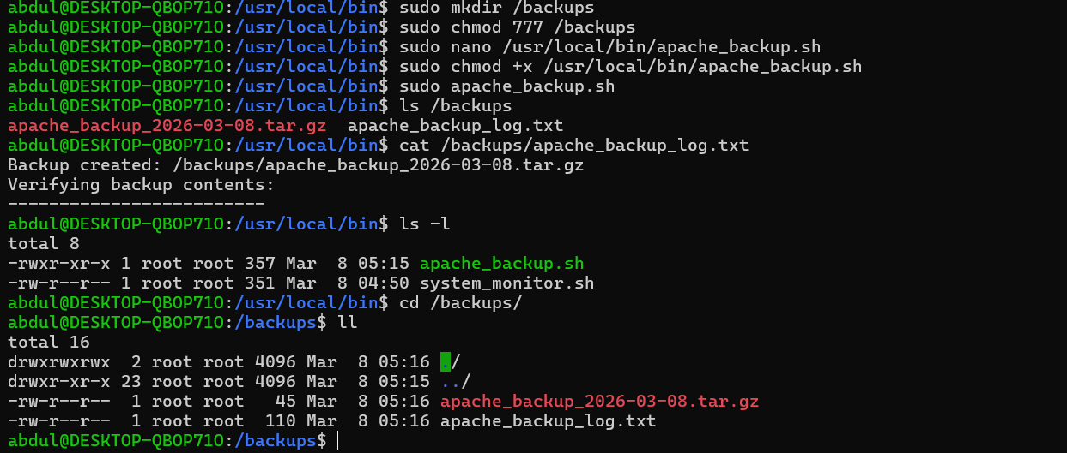

sudo nano /usr/local/bin/nginx_backup.sh
sudo chmod +x /usr/local/bin/nginx_backup.sh
sudo nginx_backup.sh
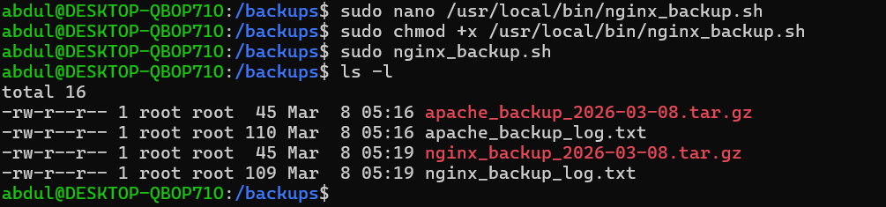

sudo crontab -e
0 0 * * 2 /usr/local/bin/apache_backup.sh
0 0 * * 2 /usr/local/bin/nginx_backup.sh
sudo crontab -l
